INFO-6068 Status Meeting Minutes – Team Pro-Test

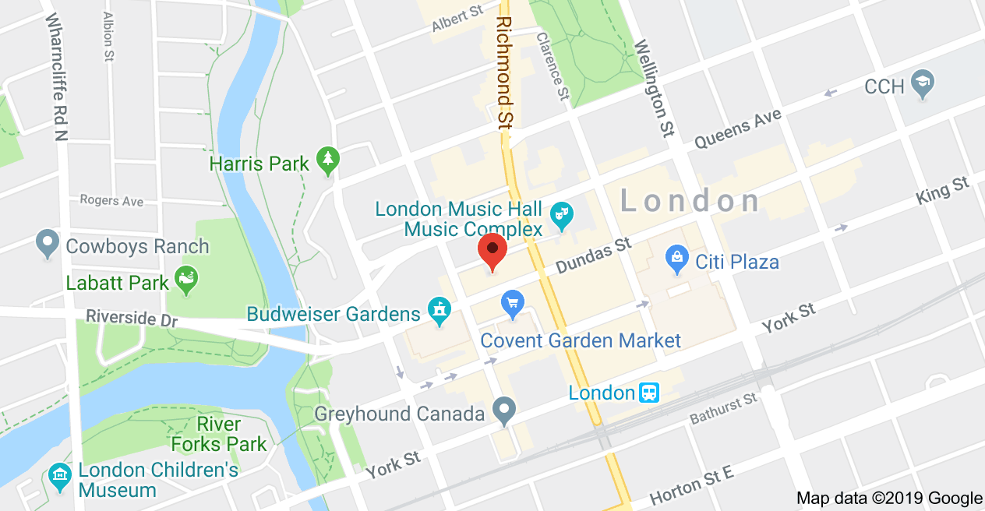

|  |  |  |  |
| --- | --- | --- | --- |
| Project: |  | | |
| **Project Manager:** | Francisco Gomez | **Business Responsible:** |  |
| Date: | 24-Oct-2019 | **Phase:** |  |
| Time: | 6:00pm | Location: | Fanshawe Downtown Campus – Room 415  130 Dundas Street  London ON |
| Prepared by: | Ralph Anonuevo | Schedule: | **From:** 6:00pm  **To:** 7:00pm |

| Attendees (Present, Absent) | | | | | |
| --- | --- | --- | --- | --- | --- |
| Invited | Attended | Invited | Attended | Invited | Attended |
| Francisco Gomez | **√** |  |  |  |  |
| Ralph Anonuevo | **√** |  |  |  |  |
| Lyan Joy Limjap | **√** |  |  |  |  |
| Daniel Gilbert | **√** |  |  |  |  |
| Mrinal Chopra | **√** |  |  |  |  |
| Rose Maria George | **√** |  |  |  |  |
| Anand Karithadathil Baby | **√** |  |  |  |  |

| Objective(s): |
| --- |
| 1. Review Current Project Activities 2. Next Steps 3. General Discussion 4. Define Procedures for Rotating Manager and Scribe roles 5. Discuss Project Plan Initiation 6. Establish Main forms of communication |

| Agenda/Meeting Highlights | |
| --- | --- |
| Topic # | Agenda/Meeting Highlights: |
|  | Updated traceability matrix |
|  | Updated use case |
|  | Updated Test Cases |
|  | Add Test cases for the design of the application |
|  | Franciso will do the presentation for October 29, 2019 |
|  | Answered clarifications in Question for test cases. |
|  |  |
|  |  |
|  |  |
|  |  |
|  |  |

| Action/Issues List | | | | | |
| --- | --- | --- | --- | --- | --- |
| # | Date | Actions | Owner | Target Date | Action Status |
|  | October 24, 2019 | The team updated Admin User Creation Test Cases to meet Password Requirements | Project team | 10-16-19 | Open |
|  | October 24, 2019 | Conflict between sets of requirements regarding deletion of users | Project team | 10-16-19 | Open |
|  | October 24, 2019 | Team missed some Requirements for Passwords | Project team | 10-16-19 | Closed |
|  | October 24, 2019 | Create meeting agenda for next week | Project manager | 10-16-19 | Open |
|  | October 24, 2019 | Update Final Project Plan | Project Manager | 12-05-19 | Open |
|  |  |  |  |  |  |
|  |  |  |  |  |  |
|  |  |  |  |  |  |
|  |  |  |  |  |  |

| Next Meeting | | |
| --- | --- | --- |
| Date | Room | Duration |
| October 31, 2019 | Room 415 LBD | 6:00pm – 7:00pm |